*2018 Future Frame Prediction for Anomaly Detection – A New Basline*

Generator: U-Net, Discriminator: PatchGAN discriminator.

They first train a predictor that can well predict the future frame for normal training data.

They propose to add an optical flow constraint into the objective function to guarantee the motion consistency for normal events in training set.

Given a video with consecutive (t + 1) frames $\left\{I_{1},I_{2}, …, I_{t}, I_{t+1} \right\}$, they sequentially stack all the first t frames and use them to predict next future frame ${\hat{I}}_{t+1}$ which is close to $I_{t+1}$.

To minimize the distance between ${\hat{I}}_{t+1}$ and $I_{t+1}$, they use gradient loss. To ensure the motion consistency, they use optical flow loss between $I_{t+1}$ with $I_{t}$ and ${\hat{I}}_{t+1}$ with $I_{t}$.

Finally, the difference between prediction and original image determines whether it is abnormal.

In the testing phase, if a frame agrees with its prediction, it potentially corresponds to a normal event.

Their solution agrees with the concept of anomaly detection that normal events are predictable while abnormal ones are unpredictable.

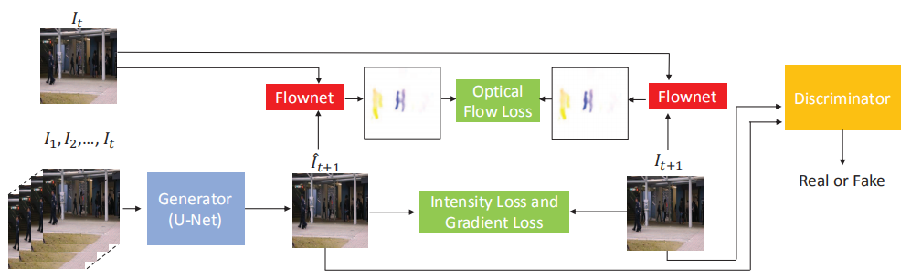

They assume that normal events can be well predicted, so that they can use the difference between predicted frame $\hat{I}$ and its ground truth $I$ for anomaly detection.

Peak Signal to Noise Ratio (PSNR) is a better way for image quality assessment.

$$PSNR\left(I,\hat{I}\right)=10\log_{10}{\frac{{\left[\max_{\hat{I}}\right]}^{2}}{\frac{1}{N}\sum_{i=0}^{N}{{\left(I_{i}-{\hat{I}}_{i}\right)}^{2}}}}$$

High PSNR of the *t-th* frame indicates that it is more likely to be normal.

After calculating each frame’s PSNR of each testing video, they normalize PSNR of all frames in each testing video to the range [0, 1] and calculate the regular score for each frame:

$$S\left(t\right)=\frac{PSNR\left(I_{t},{\hat{I}}_{t}\right)-\min_{t}{PSNR\left(I_{t},{\hat{I}}_{t}\right)}}{\max_{t}{PSNR\left(I_{t},{\hat{I}}_{t}\right)-\min_{t}{PSNR\left(I_{t},{\hat{I}}_{t}\right)}}}$$

Then they can set a threshold to distinguish regular or irregular frames.

A popular evaluation metric is to calculate the Receiver Operation Characteristic (ROC) by gradually changing the threshold of regular scores.

Then the Area Under Curve (AUC) is cumulated to a scalar for performance evaluation. A higher value indicated better anomaly detection performance.